**Unit 6 Diagrams**

Corey Crooks

Purdue University Global

IT213 – Bram Lewis

June 23, 2021

Use case diagrams and class diagrams are both essential tools to plot out the logic circuit involved in any interactional environment. The class diagram details specific entities involved in the aforementioned environment as well as any functions that could be associated with them. This could for example have a StoreLocation entity for retail work, and list attributes such as times in which the store opens, closes, and so forth. A few of the functions associated could be OpenStore(), CloseStore(), and even BuildLocation()—although they aren’t limited to just that.

A use case diagram on the other hand details actors and their specific interactions with your environment. Using the same retail environment, this could look something like having Employee, and Customer on the outside of a box, while actions like ‘Sell Product’ and ‘Buy Product’ are on the inside. Lines would be drawn from both actors to ‘Buy Product’, but only one additional line would be drawn from ‘Sell Product’ to Employee. This would indicate that the employee has the power to both buy and sell products, but customers only have the power to buy products. For further details, both diagrams are listed below.

Class Diagram for Automobile Shop:

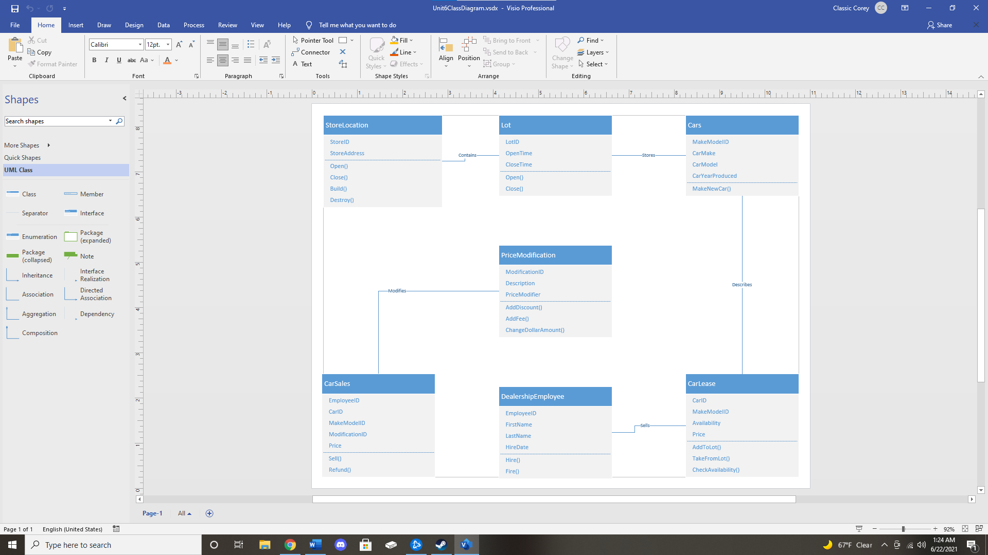

Case Diagram for Class Registration:

